Abstract format – place your title here formatted as shown here in bold: use Times New Roman font and do not capitalise first letters or whole title
RG Richards¹, M Alini¹, C Archer²
¹ AO Research Institute, AO Foundation, Davos, CH. ² Connective Tissue Biology Labs, School of Biosciences, Cardiff University, Wales

INTRODUCTION: The proceedings will be typeset, for publication as a supplement in the eCM journal. Hence, abstracts must adhere to the contained style. The required styles illustrated in this Microsoft WORD document, must be used as a template for production of abstracts, by replacing the relevant text with your own, by cutting and pasting of unformatted text to maintain the present format. IMPORTANT: DO NOT INTERFERE WITH HEADER OR FOOTER.
METHODS: All abstracts must be formatted to a single A4 page (210 x 297 mm). The top margin should be set to 15 mm, bottom margin to 25 mm, and 1eft and right margins to 20 mm. The entire document is set to 2 columns with 10 mm of intercolumn spacing (giving a column width of 80 mm). The body of the document should be set in 11 pt Times New Roman, justified, with single line-spacing. Do not use fonts other than Times New Roman or Symbol in the document (including equations and figures).
Title should be in bold, styled as shown. Authors should be listed consecutively (as above) by initials and last name, punctuated as shown. Authors may be hyperlinked to the e-mail address (as shown above). Affiliation should be indicated with superscipted suffix Arabic numerals. Do not append degrees, professional designations, etc., to names. Affiliations should be listed consecutively and may be hyperlinked to a web page (as examples above). Sample reference entries [l-3] are given in the References section. References should be set as one block, as below, and a maximum of four references may be used.
RESULTS: Figures should use Figure style and have the caption below them. Tables should use Table style and have the caption above them. Figure and table caption styles are FigCaption and TableCaption, respectively. Scanned figures should have a minimum resolution of 200 dpi for an 80 mm figure width. Equations should use Equation style:
k(t) = μ exp(-μ t/η) 1(t) (1)
and should be tab centred, with the number in parentheses on the right.
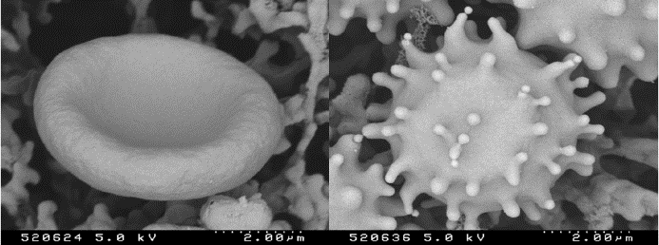
Fig. 1: Images of cells in this case – please use the Picture Tools facility to compress the images to 200dpi for printing, before saving. Include Scale Line value if not already embedded in the image.
Table 1. Relative allocation and amount of resources in research.
 | Amount of Resources | Allocation Freedom
Industry | high | constrained
Academic | Low | unconstrained

DISCUSSION & CONCLUSIONS: Abstracts must not exceed one page. Do NOT tamper with the header or footer. Please submit the abstract as a Microsoft Word document. Only electronic submissions will be accepted. The abstracts may be submitted via e-mail (attachment) or post (IBM-compatible diskette or CD-ROM labelled with abstract title and corresponding author, one abstract per folder).
REFERENCES: ¹ M. Ziegler (1991) Essentials of Writing Biomedical Research Papers, McGraw-Hill, Inc. ² I.R. Spears, M. Pfleiderer, E. Schneider, et al (2000) J Biomech 33:1471-77. ³ A.R Poole, M. Alini, and A Hollander (1995) Chondrocytes and cartilage destruction in Mechanisms and Models in Rheumatoid Arthritis (eds B. Henderson, J. Edwards, and R. Pettipher) Academic Press, pp 163-204.
ACKNOWLEDGEMENTS: This template was modified with kind permission from eCM Journal.

