EDUCATION SYMPOSIUM:
CREATING A WORLD CLASS TEACHING SYSTEM

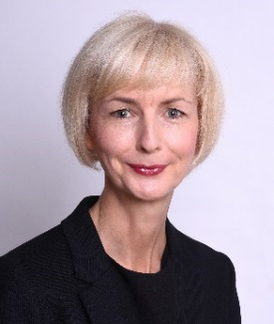
Professor Moira Hulme
Professor of Teacher Education
Research Leader, Teacher Education: Leadership Curriculum & Inclusion Research Group
Education and Social Research Institute
m.hulme@mmu.ac.uk
+44 (0)161 247 2024

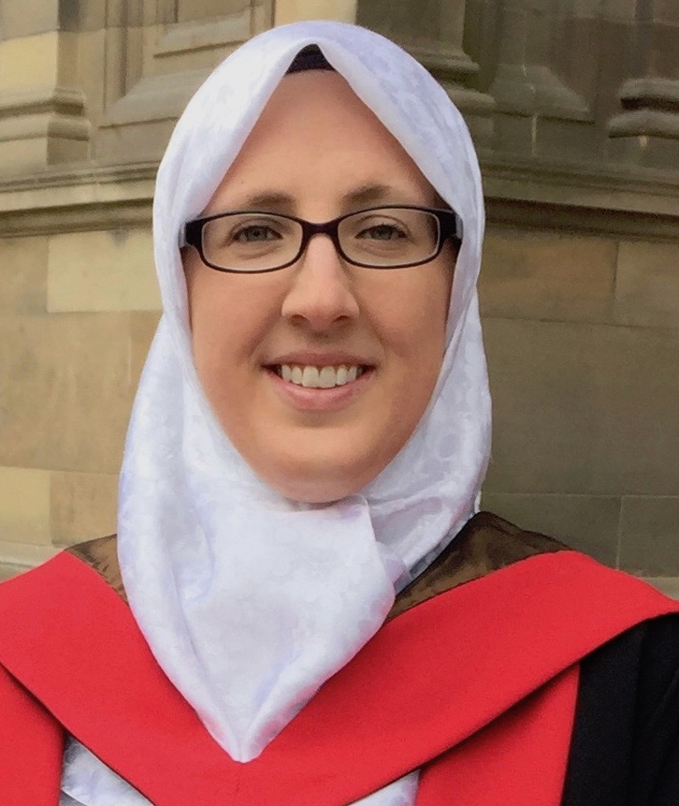

Dr Emilee Rauschenberger
Senior Research Fellow
Education and Social Research Institute
e.rauschenberger@mmu.ac.uk
+44 (0)161 247 5371

Amanda Smith
Principal Lecturer Education
Head of STEM Education Manchester
School of Teacher Education and Development
a.m.smith@mmu.ac.uk
+44 (0)161 247 2063

Richard Dunk
Lecturer Science Education
School of Teacher Education and Development
richard.dunk@mmu.ac.uk
+44 (0)161 247 2299

Fiona Haniak-Cockerham
Senior Lecturer Mathematics Education
School of Teacher Education and Development
f.cockerham@mmu.ac.uk
+44 (0)161 247 2075

THE EDUCATION & SOCIAL RESEARCH INSTITUTE

Centre Director: Professor Kate Pahl

The Education and Social Research Institute (ESRI) at Manchester Metropolitan University is recognised as an internationally leading centre for educational research. ESRI combines high quality research with significant volume. We have an outstanding portfolio of research grants and publications, regularly organise national and international seminars and workshops, and offer several doctoral studentship awards each year. We are members of the ESRC-funded White Rose Doctoral Training Partnership.

ESRI is an important engine of quality and ambition in the Faculty of Education, which is one of the few remaining ‘full service’ Education faculties in the UK (i.e. combining high quality research with a full range of large scale undergraduate and postgraduate primary and secondary teacher training, and education studies programmes). http://www2.mmu.ac.uk/education/

Our research activities comprise five Research and Knowledge Exchange groups. Each group operates under professorial leadership:
- Children and Childhood (Professor Rachel Holmes)
- Youth and Community (Professor Gabrielle Ivinson)
- STEM Education and Learning Technologies (Professor Cathy Lewin)
- Teacher Education: Leadership, Curriculum and Inclusion (Professor Moira Hulme)
- Theory and Methodology (Professor Maggie MacLure).

TEACHER EDUCATION: LEADERSHIP, CURRICULUM & INCLUSION

RESEARCH GROUP

Research Leader: Professor Moira Hulme

The Teacher Education, Leadership & Curriculum research group brings together researchers with an interest in policy and practice in the field of professional learning, educational leadership and inclusive education. The group is a hub for the development of research-informed professional programmes at Manchester Metropolitan’s Faculty of Education. Our members work with practitioners and policy makers in primary and secondary education, further and higher education. Our research encompasses initial teacher education (pre-service), the early career phase and career-long professional learning. The group’s research programme has five strands: (i) research on policy; (ii) inclusive education for diverse learners; (iii) pedagogical innovation; (iv) educational leadership and management; and, (v) educational assessment. We welcome and maintain active collaborations with schools, colleges, local authorities, Teaching Schools and education consortia; and participate in regional, national and international networks to promote high quality research in and for teacher education and the wider education workforce.

Areas of interest:
- International policies and practices in the preparation, induction and continuing development of teachers
- Research-led approaches to inclusive learning in professional development
- Developing and evaluating research-informed pedagogical practices
- The role of values in educational leadership and management
- Use and value of different approaches to assessment and its implications for policy

